**EXPERIMENT NO1**

AIM: Realization of Basic Gates

APPARATUS: Power Supply, Breadboard, Connecting wires, IC’s (7400, 7402, 7404, 7408, 7432, and 7486)

THEORY:

AND Gate: The AND operation is defined as the output as (1) one if and only if all the inputs are (1) one. 7408 is the two Inputs AND gate IC.A&B are the Input terminals &Y is the Output terminal.

Y = A.B

OR Gate: The OR operation is defined as the output as (1) one if one or more than 0 inputs are (1) one. 7432 is the two Input OR gate IC. A&B are the input terminals & Y is the Output terminal.

Y = A + B

NOT GATE: The NOT gate is also known as Inverter. It has one input (A) & one output (Y). IC No. is 7404. Its logical equation is,

Y = A NOT B, Y = A’

NAND GATE: The IC no. for NAND gate is 7400. The NOT-AND operation is known as NAND operation. If all inputs are 1 then output produced is 0. NAND gate is inverted AND gate.

Y = (A. B)’

NOR GATE: The NOR gate has two or more input signals but only one output signal. IC 7402 is two I/P IC. The NOT- OR operation is known as NOR operation. If all the inputs are 0 then the O/P is 1. NOR gate is inverted OR gate.

Y = (A+B)’

EX-OR GATE: The EX-OR gate can have two or more inputs but produce one output. 7486 is two inputs IC. EX-OR gate is not a basic operation & can be performed using basic gates.



The pin diagram of various ICs are shown in figure.

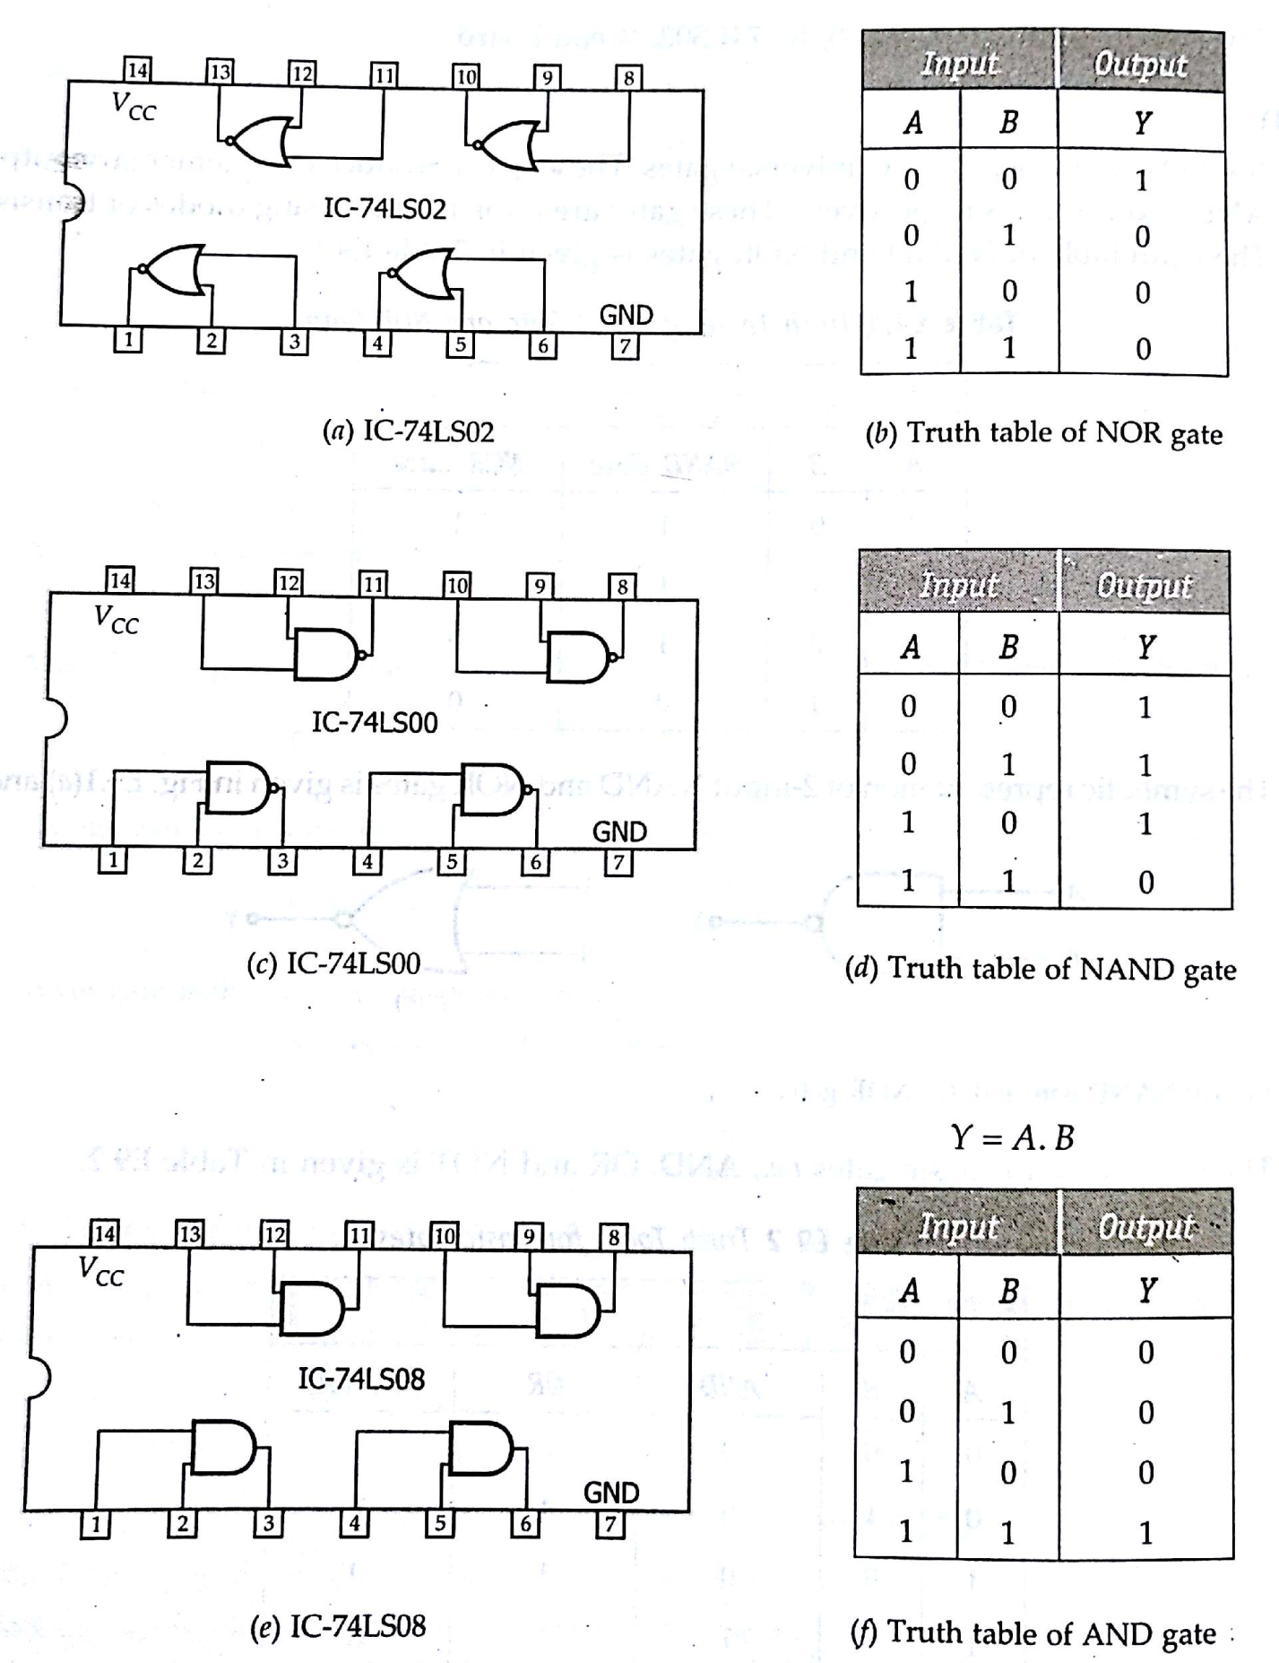

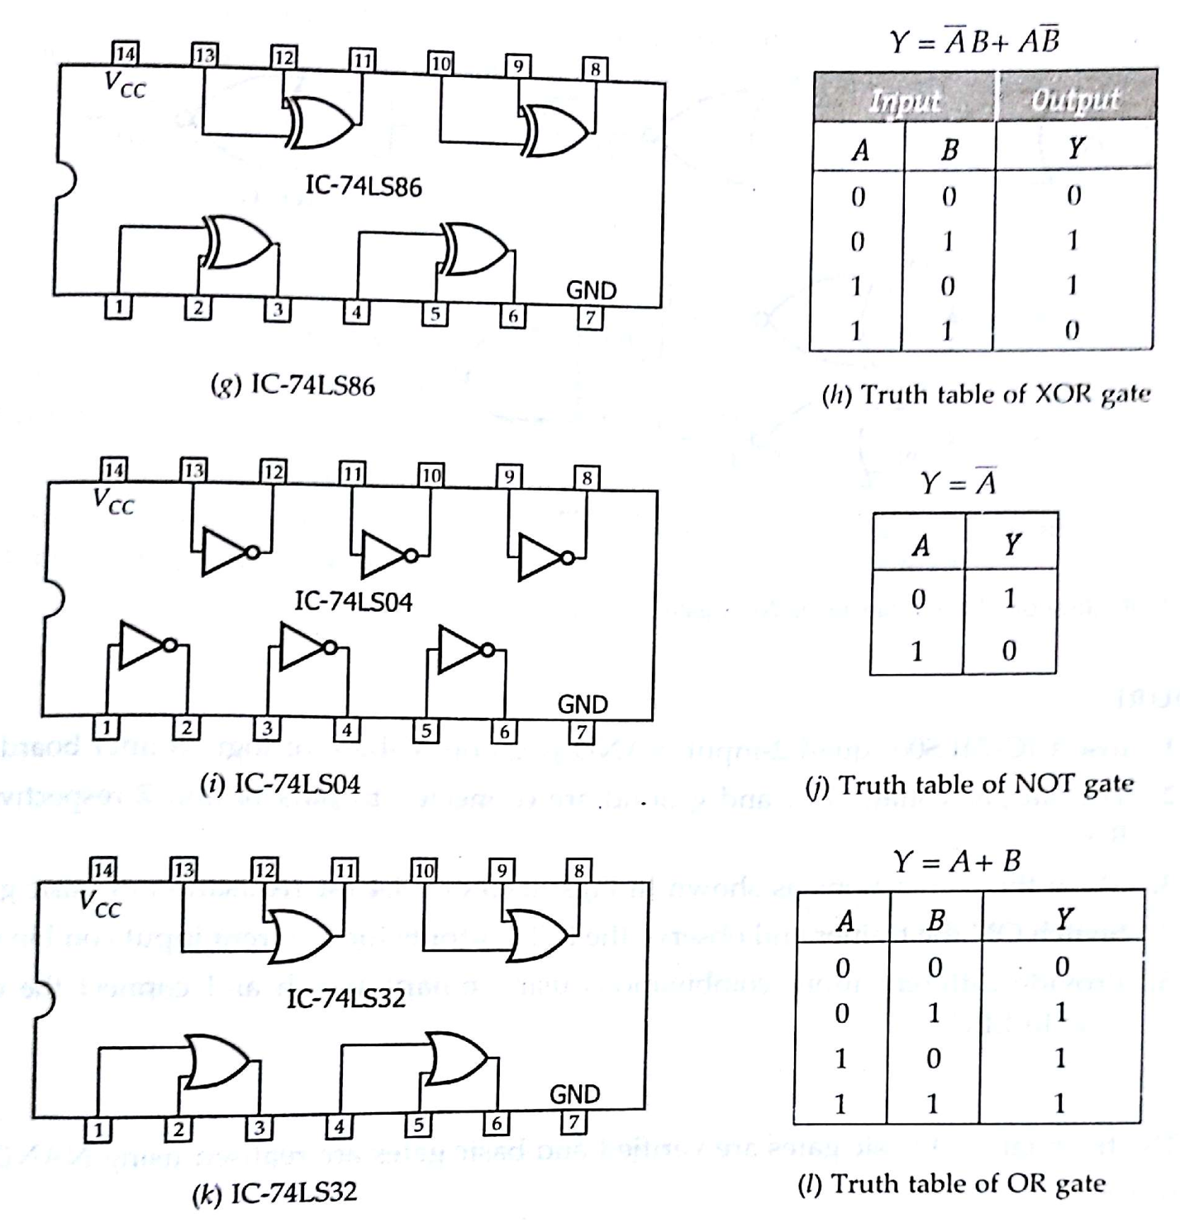

**PROCEDURE:**

(a) Fix the IC’s on breadboard & give the supply.

(b) Connect the +ve terminal of supply to pin 14 & -ve to pin 7.

(c) Give input at pin 1, 2 & take output from pin 3. It i s same for all the ICs except NOT & NOR IC.

(d) For NOR, pin 1 is output & pin 2&3 are inputs.

(e) For NOT, pin 1 is input & pin 2 is output.

(f) Note the values of output for different combination of inputs & draw the TRUTH TABLE.

**RESULT:** We have learnt all the gates ICs according to the IC pin diagram.

**PRECAUTIONS:**

1. Make the connection s according to the IC pin diagram.

2. The connections should be tight.

**3.** The Vcc and ground should be applied carefully at the specified pin only.

**VIVA VOCE QUESTIONS:**

1. Why NAND &amp; NOR gates are called universal gates?

2. Give the truth table for EX-NOR (EX-OR+NOT) and realize using NAND gates

3. Realize the given logic function using NAND gates?

f = ABC + ABC + ABC